**Release Version**

🎦 **Video:**

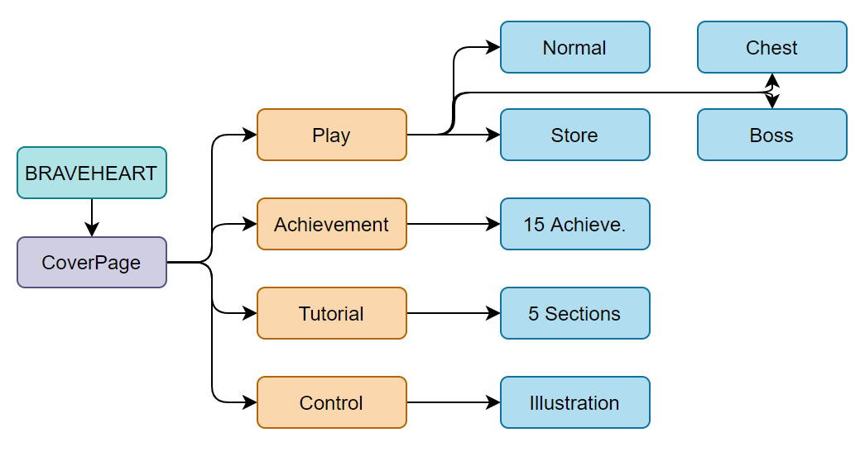

🔱 **Game Flow:**

1. The prologue of the adventure is about to be unveiled…

“Where am I? Help me get out of here! Help!!!” (Fig.1)

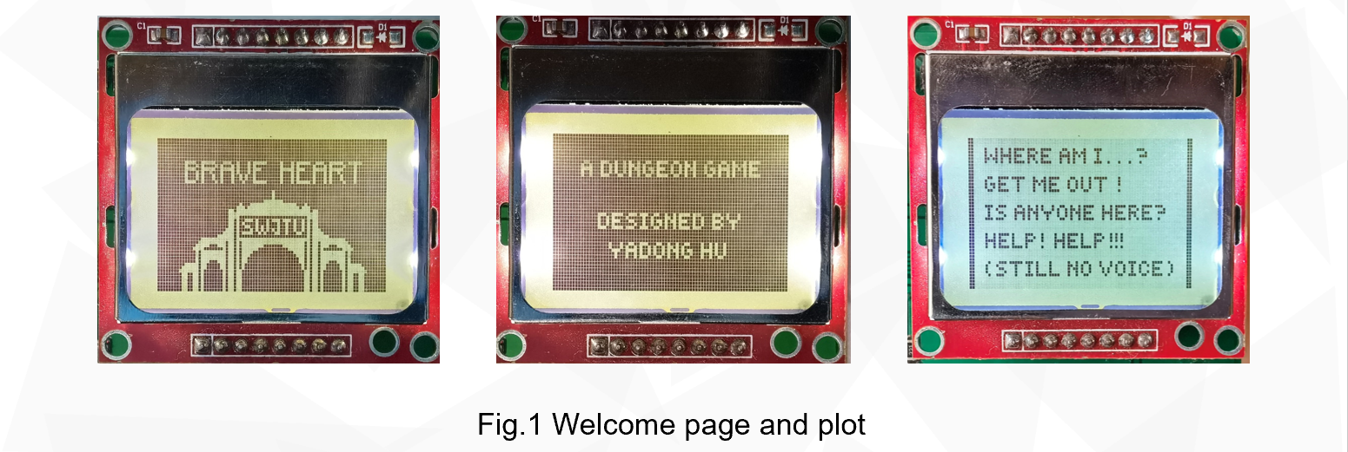

You are now in a dungeon, slay enemies and return to the ground!

1. First, you need to know how to move and fire (Fig.2).

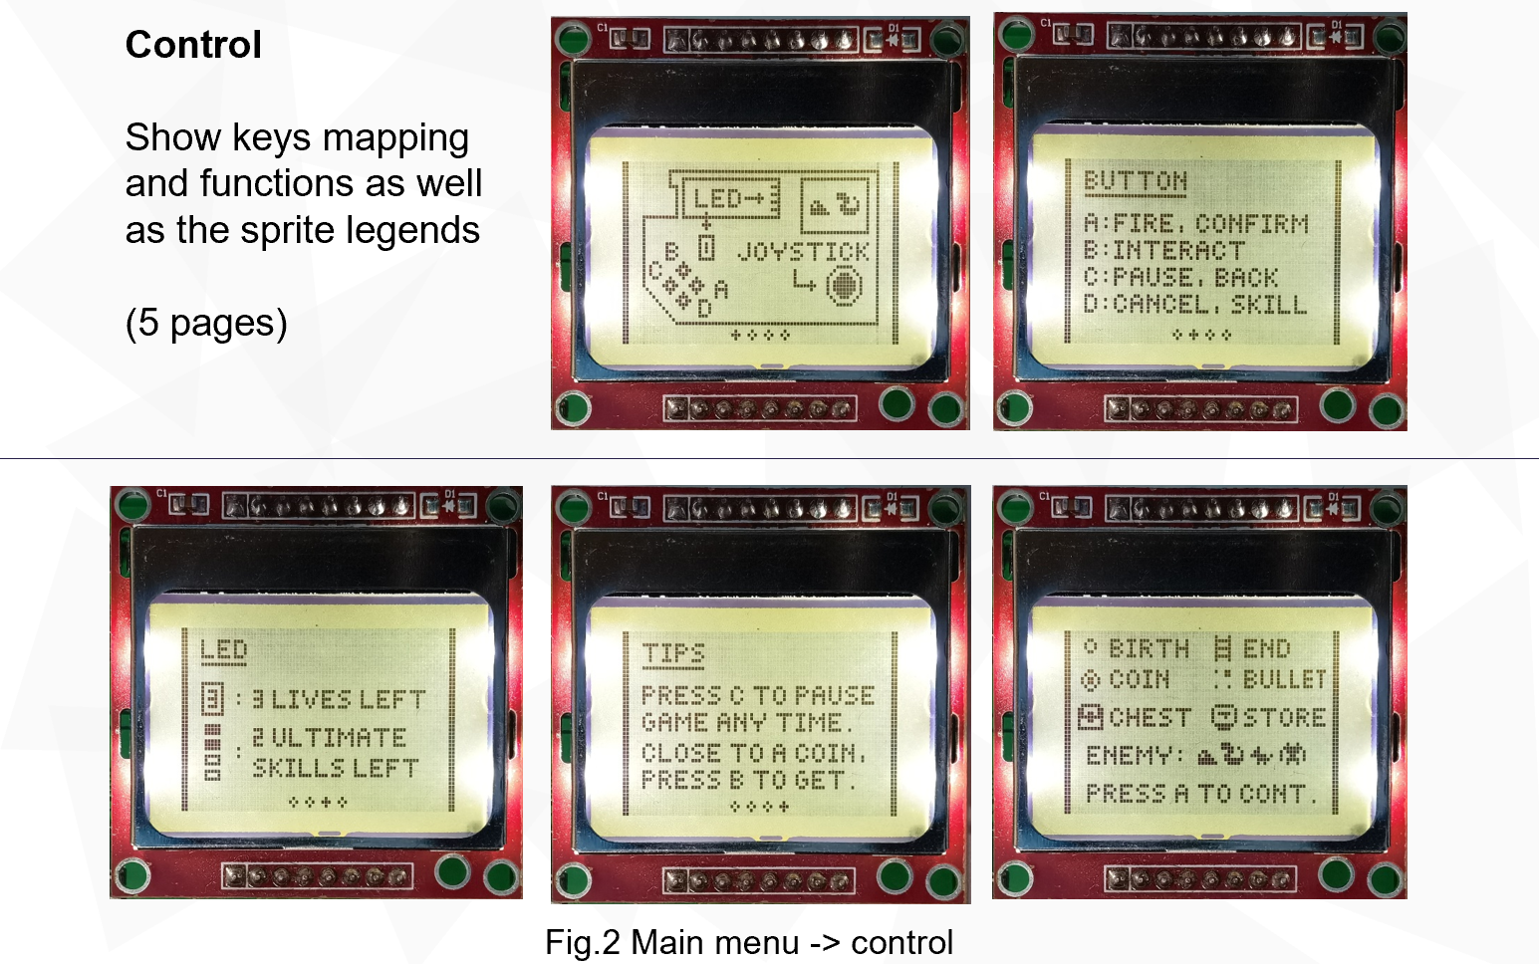

1. Next, complete 5 tutorials to get yourself ready! (Fig.3)

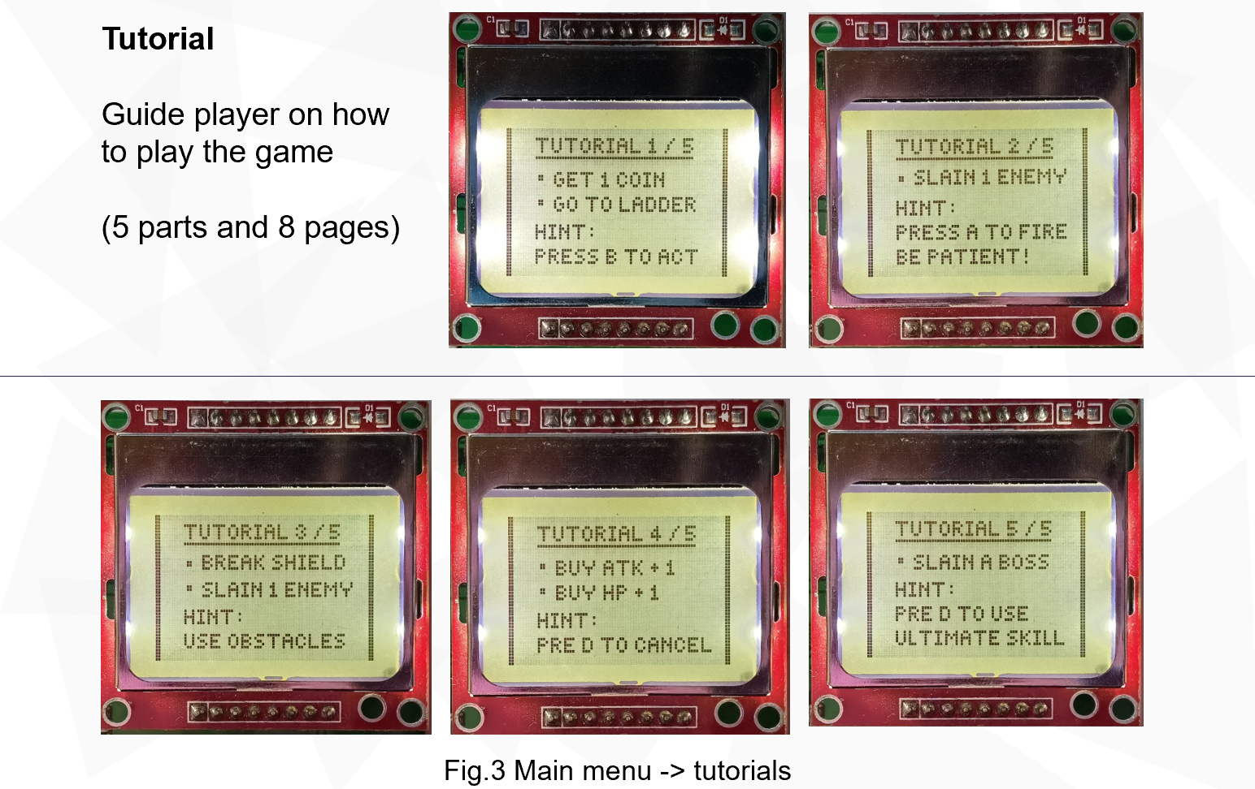

1. Now, you can show off your skills in real adventure! (Fig.4)

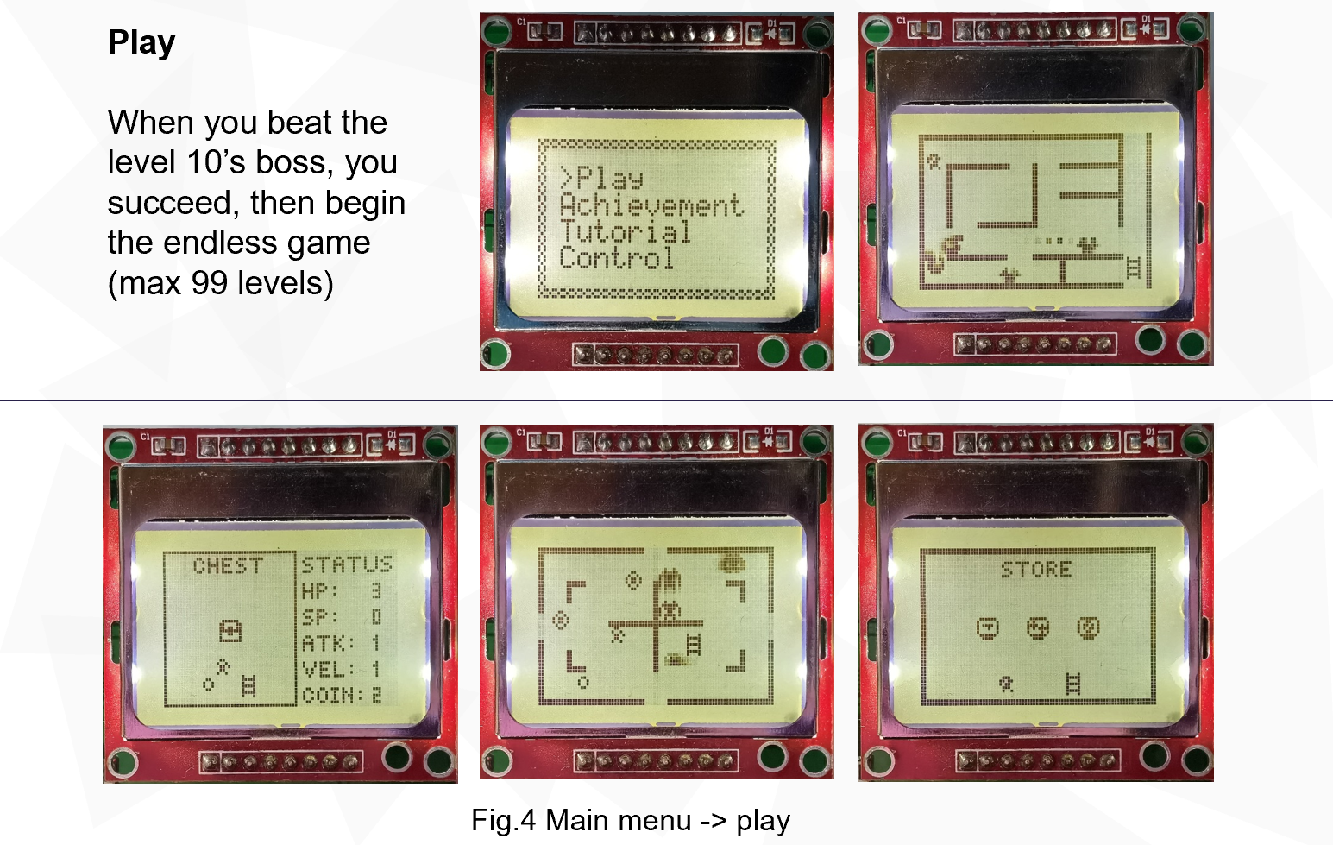

All elements including the enemies, mazes, coins are randomly generated! You may find bosses, chests, and stores in this endless-level dungeon!

You can fire to enemies, use ultimate skills, buy something to boost your abilities! Different kinds of enemies may even attack player proactively.

1. Tired of adventure? Let’s have a rest and appreciate the records you have made in games! (Fig.5)

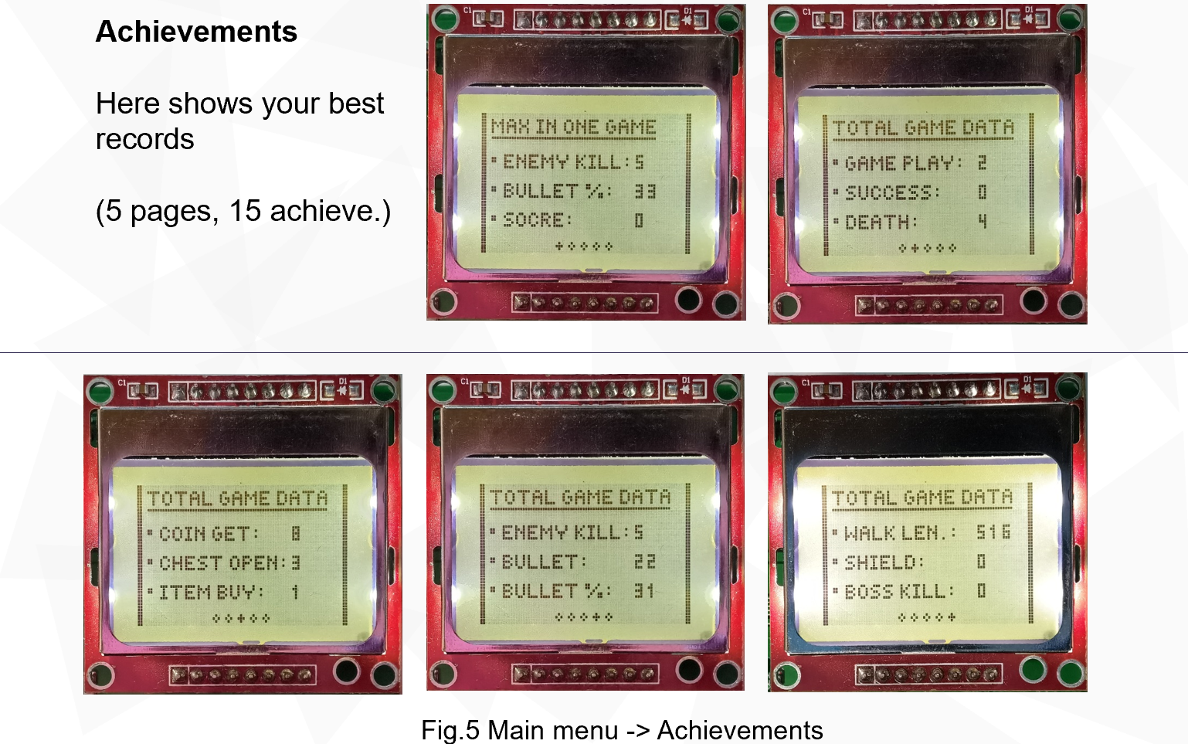

🏁 **Conclusion:**

Never be afraid of failures, keep going man, you can always challenge yourself here!

**📃 PDF version:**